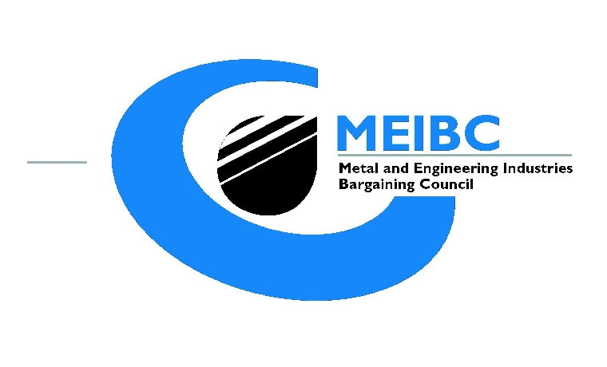

1st Floor Metal Industries House, 42 Anderson Street, Johannesburg
All correspondence should be addressed to the Secretary at:
P O Box 9381
Johannesburg 2000
Tel: 834 4660
Fax: 834 6853

Case No. MEGA

In the matter between:

Applicant:

and

Respondent:

NOTICE OF WITHDRAWAL

The Applicant party hereby records that the dispute, alleging an _UNFAIR DISMISSAL_ recorded under the aforementioned reference number at the MEIBC CDR, is withdrawn.

THIS DONE AND SIGNED AT _______________ ON _____ DAY OF _________ 2022.

_______________________
EMPLOYEE PARTY

WITNESS ___________________

WITNESS ___________________

